COMP 1630 Project 2 - SQL queries
Jae Sung Kim

Table of Contents

Φ Checking for existing DB . . . . . . . . . . . . . . . . . . . . . . . . . . . . . . . . . . . . . . . . . . . 4

1 Part A Database and Tables
1.1 Part A Question 1 . . . . . . . . . . . . . . . . . . . . . . . . . . . . . . . . . . . . . . . . . . . . . 5
1.2 Part A Question 2 . . . . . . . . . . . . . . . . . . . . . . . . . . . . . . . . . . . . . . . . . . . . . 5
1.3 Part A Question 3 . . . . . . . . . . . . . . . . . . . . . . . . . . . . . . . . . . . . . . . . . . . . . 6
1.4 Part A Question 4 . . . . . . . . . . . . . . . . . . . . . . . . . . . . . . . . . . . . . . . . . . . . . 8
1.5 Part A Question 5 . . . . . . . . . . . . . . . . . . . . . . . . . . . . . . . . . . . . . . . . . . . . . 10
1.6 Part A Question 6 . . . . . . . . . . . . . . . . . . . . . . . . . . . . . . . . . . . . . . . . . . . . . 11

2 Part B SQL Statements
2.1 Part B Question 1 . . . . . . . . . . . . . . . . . . . . . . . . . . . . . . . . . . . . . . . . . . . . . 14
2.2 Part B Question 2 . . . . . . . . . . . . . . . . . . . . . . . . . . . . . . . . . . . . . . . . . . . . . 16
2.3 Part B Question 3 . . . . . . . . . . . . . . . . . . . . . . . . . . . . . . . . . . . . . . . . . . . . . 17
2.4 Part B Question 4 . . . . . . . . . . . . . . . . . . . . . . . . . . . . . . . . . . . . . . . . . . . . . 19
2.5 Part B Question 5 . . . . . . . . . . . . . . . . . . . . . . . . . . . . . . . . . . . . . . . . . . . . . 21
2.6 Part B Question 6 . . . . . . . . . . . . . . . . . . . . . . . . . . . . . . . . . . . . . . . . . . . . . 23
2.7 Part B Question 7 . . . . . . . . . . . . . . . . . . . . . . . . . . . . . . . . . . . . . . . . . . . . . 25
2.8 Part B Question 8 . . . . . . . . . . . . . . . . . . . . . . . . . . . . . . . . . . . . . . . . . . . . . 27
2.9 Part B Question 9 . . . . . . . . . . . . . . . . . . . . . . . . . . . . . . . . . . . . . . . . . . . . . 29
2.10 Part B Question 10 . . . . . . . . . . . . . . . . . . . . . . . . . . . . . . . . . . . . . . . . . . . 31

3 Part C INSERT, UPDATE, DELETE and VIEWS Statements
3.1 Part C Question 1 . . . . . . . . . . . . . . . . . . . . . . . . . . . . . . . . . . . . . . . . . . . . . 33
3.2 Part C Question 2 . . . . . . . . . . . . . . . . . . . . . . . . . . . . . . . . . . . . . . . . . . . . . 34
3.3 Part C Question 3 . . . . . . . . . . . . . . . . . . . . . . . . . . . . . . . . . . . . . . . . . . . . . 34
3.4 Part C Question 4 . . . . . . . . . . . . . . . . . . . . . . . . . . . . . . . . . . . . . . . . . . . . . 35
3.5 Part C Question 5 . . . . . . . . . . . . . . . . . . . . . . . . . . . . . . . . . . . . . . . . . . . . . 36
3.6 Part C Question 6 . . . . . . . . . . . . . . . . . . . . . . . . . . . . . . . . . . . . . . . . . . . . . 37
3.7 Part C Question 7 . . . . . . . . . . . . . . . . . . . . . . . . . . . . . . . . . . . . . . . . . . . . . 38
3.8 Part C Question 8 . . . . . . . . . . . . . . . . . . . . . . . . . . . . . . . . . . . . . . . . . . . . . 40
3.9 Part C Question 9 . . . . . . . . . . . . . . . . . . . . . . . . . . . . . . . . . . . . . . . . . . . . . 42
3.10 Part C Question 10 . . . . . . . . . . . . . . . . . . . . . . . . . . . . . . . . . . . . . . . . . . . 44

4 Part D Stored Procedures and Triggers
4.1 Part D Question 1 . . . . . . . . . . . . . . . . . . . . . . . . . . . . . . . . . . . . . . . . . . . . . 46
4.2 Part D Question 2 . . . . . . . . . . . . . . . . . . . . . . . . . . . . . . . . . . . . . . . . . . . . . 48
4.3 Part D Question 3 . . . . . . . . . . . . . . . . . . . . . . . . . . . . . . . . . . . . . . . . . . . . . 50
4.4 Part D Question 4 . . . . . . . . . . . . . . . . . . . . . . . . . . . . . . . . . . . . . . . . . . . . . 52
4.5 Part D Question 5 . . . . . . . . . . . . . . . . . . . . . . . . . . . . . . . . . . . . . . . . . . . . . 53
4.6 Part D Question 6 . . . . . . . . . . . . . . . . . . . . . . . . . . . . . . . . . . . . . . . . . . . . . 54
4.7 Part D Question 7 . . . . . . . . . . . . . . . . . . . . . . . . . . . . . . . . . . . . . . . . . . . . . 55
4.8 Part D Question 8 . . . . . . . . . . . . . . . . . . . . . . . . . . . . . . . . . . . . . . . . . . . . . 56
4.9 Part D Question 9 . . . . . . . . . . . . . . . . . . . . . . . . . . . . . . . . . . . . . . . . . . . . . 58

4 Part D Stored Procedures and Triggers
5.1 Query File . . . . . . . . . . . . . . . . . . . . . . . . . . . . . . . . . . . . . . . . . . . . . . . . . . . 60

1 Part A - Database and Tables

Φ Checking for existing DB
Query

USE master; --select master which has all the databases
GO

IF EXISTS --checking for the existence of 'Cus_Orders' database --deletes it if found
(
SELECT *
FROM sysdatabases
WHERE name='Cus_Orders'
)
BEGIN
PRINT('Dropping database...')
DROP DATABASE Cus_Orders;
END
GO

Results
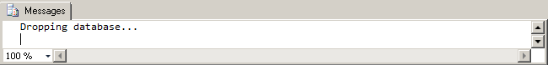
Notes and Observations
- Deletion of databases requires that the focus is on “master” or else the operation fails

1 Part A - Database and Tables

1.1 Part A Question 1
Create a database called Cus_Orders.
Query

USE master;
GO

/*#1*/

CREATE DATABASE Cus_Orders;
GO

USE Cus_Orders;
GO

Results
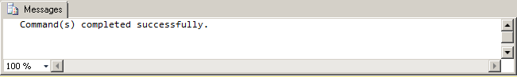

1.2 Part A Question 2

Create a user defined data types for all similar Primary Key attribute columns (e.g.order_id, product_id,title_id), to ensure the same data type, length and null ability. See pages 12/13 for specifications.

Query

CREATE TYPE uniqid FROM CHAR(5) NOT NULL;
CREATE TYPE intid FROM int NOT NULL;
GO

1 Part A - Database and Tables

1.3 Part A Question 3
Create the following tables (see column information on pages 12 and 13 ):
customers
orders
order_details
products
shippers
suppliers
titles

Query (Part 1)
CREATE TABLE customers
(
customer_id uniqid,
name VARCHAR(50),
contact_name VARCHAR(30),
title_id CHAR(3) NOT NULL,
address VARCHAR(50),
city VARCHAR(20),
region VARCHAR(15),
country_code VARCHAR(10),
country VARCHAR(15),
phone VARCHAR(20),
fax VARCHAR(20)
);

CREATE TABLE orders
(
order_id intid,
customer_id uniqid,
employee_id int NOT NULL,
shipping_name VARCHAR(50),
shipping_address VARCHAR(50),
shipping_city VARCHAR(20),
shipping_region VARCHAR(15),
shipping_country_code VARCHAR(10),
shipping_country VARCHAR(15),
shipper_id int NOT NULL,
order_date datetime,
required_date datetime,
shipped_date datetime,
freight_charge money
);

1 Part A - Database and Tables

Query (Part 2)
CREATE TABLE order_details
(
order_id intid,
product_id intid,
quantity int NOT NULL,
discount float NOT NULL
);

CREATE TABLE products
(
product_id intid,
supplier_id int NOT NULL,
name VARCHAR(40),
alternate_name VARCHAR(40),
quantity_per_unit VARCHAR(25),
unit_price money,
quantity_in_stock int,
units_on_stock int,
reorder_level int
);

CREATE TABLE shippers
(
shipper_id int IDENTITY(1,1) NOT NULL,
name VARCHAR(20) NOT NULL
);

CREATE TABLE suppliers
(
supplier_id int IDENTITY(1,1) NOT NULL,
name VARCHAR(40) NOT NULL,
address VARCHAR(30),
city VARCHAR(20),
province CHAR(2)
);

CREATE TABLE titles
(
title_id char(3) NOT NULL,
description VARCHAR(35) NOT NULL
);
GO
1 Part A - Database and Tables

1.4 Part A Question 4
Set the primary keys and foreign keys for the tables.
Query (Setting Pks)

ALTER TABLE customers
ADD PRIMARY KEY (customer_id);
GO

ALTER TABLE orders
ADD PRIMARY KEY (order_id);
GO

ALTER TABLE order_details
ADD PRIMARY KEY (order_id, product_id);
GO

ALTER TABLE products
ADD PRIMARY KEY (product_id);
GO

ALTER TABLE shippers
ADD PRIMARY KEY (shipper_id);
GO

ALTER TABLE suppliers
ADD PRIMARY KEY (supplier_id);
GO

ALTER TABLE titles
ADD PRIMARY KEY (title_id);
GO

1 Part A - Database and Tables

Query (Setting Fks)
ALTER TABLE orders
ADD CONSTRAINT FK_customers_orders FOREIGN KEY(customer_id)
REFERENCES customers(customer_id);
GO

ALTER TABLE orders
ADD CONSTRAINT FK_shippers_orders FOREIGN KEY(shipper_id)
REFERENCES shippers(shipper_id);
GO

ALTER TABLE order_details
ADD CONSTRAINT FK_orders_order_details FOREIGN KEY(order_id)
REFERENCES orders(order_id);
GO

ALTER TABLE order_details
ADD CONSTRAINT FK_products_order_details FOREIGN KEY(product_id)
REFERENCES products(product_id);
GO

ALTER TABLE products
ADD CONSTRAINT FK_suppliers_products FOREIGN KEY(supplier_id)
REFERENCES suppliers(supplier_id);
GO

ALTER TABLE customers
ADD CONSTRAINT FK_titles_customers FOREIGN KEY(title_id)
REFERENCES titles(title_id);
GO

1 Part A - Database and Tables

1.5 Part A Question 5
Set the constraints as follows:
Table Name | Constraint
Customer | country should default to Canada
Orders | required_date should default to today’s date plus ten days
order details table | quantity must be greater than or equal to 1
products table | reorder_level must be greater than or equal to 1  quantity_in_stock value must not be greater than 150
suppliers table | province should default to BC

Query
ALTER TABLE customers
ADD CONSTRAINT default_country
DEFAULT('Canada') FOR country;
GO

ALTER TABLE orders
ADD CONSTRAINT default_date
DEFAULT(DATEADD(DAY,10,GETDATE())) FOR order_date;
GO

ALTER TABLE order_details
ADD CONSTRAINT check_ord_quantity
CHECK(quantity>=1);
GO

ALTER TABLE products
ADD CONSTRAINT check_reorder_level
CHECK(reorder_level >=1);
GO

ALTER TABLE products
ADD CONSTRAINT check_quantity_in_stock
CHECK(quantity_in_stock <=150);
GO
ALTER TABLE suppliers
ADD CONSTRAINT default_province
DEFAULT('BC') FOR province;
GO
1 Part A - Database and Tables

1.6 Part A Question 6
Load the data into your created tables using the following files:
File name | Allocation | Number of rows
Customers.txt | Into the customers table | 91
Orders.txt | Into the orders table | 1078
order_details.txt | Into the order_details table | 2820
Products.txt | Into the products table | 77
Shippers | Into the shippers table | 3
Titles | Into the titles | 15

Query (Data load script part 1)
BULK INSERT titles
FROM 'C:\TextFiles\titles.txt'
WITH (
CODEPAGE=1252,
DATAFILETYPE = 'char',
FIELDTERMINATOR = '\t',
KEEPNULLS,
ROWTERMINATOR = '\n'
)

BULK INSERT suppliers
FROM 'C:\TextFiles\suppliers.txt'
WITH (
CODEPAGE=1252,
DATAFILETYPE = 'char',
FIELDTERMINATOR = '\t',
KEEPNULLS,
ROWTERMINATOR = '\n'
)
1 Part A - Database and Tables

Query (Data load script part 2)
BULK INSERT shippers
FROM 'C:\TextFiles\shippers.txt'
WITH (
CODEPAGE=1252,
DATAFILETYPE = 'char',
FIELDTERMINATOR = '\t',
KEEPNULLS,
ROWTERMINATOR = '\n'
)

BULK INSERT customers
FROM 'C:\TextFiles\customers.txt'
WITH (
CODEPAGE=1252,
DATAFILETYPE = 'char',
FIELDTERMINATOR = '\t',
KEEPNULLS,
ROWTERMINATOR = '\n'
)

BULK INSERT products
FROM 'C:\TextFiles\products.txt'
WITH (
CODEPAGE=1252,
DATAFILETYPE = 'char',
FIELDTERMINATOR = '\t',
KEEPNULLS,
ROWTERMINATOR = '\n'
)
1 Part A - Database and Tables

Query (Data load script part 3)
BULK INSERT order_details
FROM 'C:\TextFiles\order_details.txt'
WITH (
CODEPAGE=1252,
DATAFILETYPE = 'char',
FIELDTERMINATOR = '\t',
KEEPNULLS,
ROWTERMINATOR = '\n'
)

BULK INSERT orders
FROM 'C:\TextFiles\orders.txt'
WITH (
CODEPAGE=1252,
DATAFILETYPE = 'char',
FIELDTERMINATOR = '\t',
KEEPNULLS,
ROWTERMINATOR = '\n'
)
GO

Results
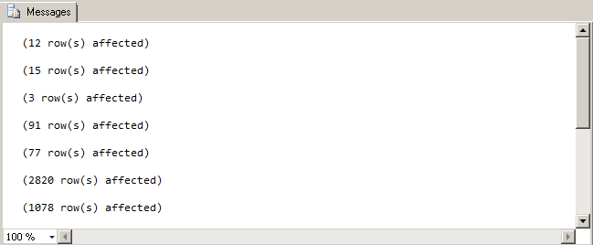
2 Part B - SQL Statements

2.1 Part B Question 1
List the customer id, name, city, and country from the customer table. Order the result set by the customer id. The query should produce the result set listed below.

customer_id | name | city | country
ALFKI | Alfreds Futterkiste | Berlin | Germany
ANATR | Ana Trujillo Emparedados y helados | México D.F. | Mexico
ANTON | Antonio Moreno Taquería | México D.F. | Mexico
AROUT | Around the Horn | London | United Kingdom
BERGS | Berglunds snabbköp | Luleå | Sweden
...
WHITC | White Clover Markets | Seattle | United States
WILMK | Wilman Kala | Helsinki | Finland
WOLZA | Wolski Zajazd | Warszawa | Poland
(91 row(s) affected)

Query
SELECT customer_id, name, city, country
FROM customers
ORDER BY customer_id;

Notes and Observations
- Ordering by 'customer_id' is determined by the first letter, then the second letter, and so on.

2 Part B - SQL Statements

Results (rows 1 to 13 from 91rows)
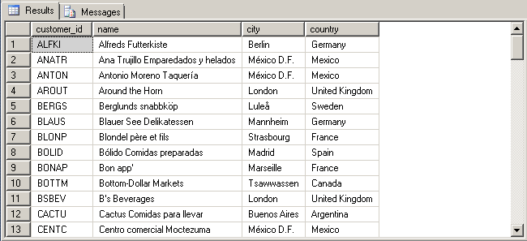

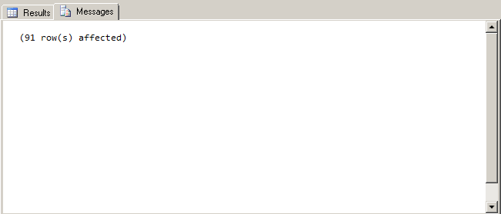

2 Part B - SQL Statements

2.2 Part B Question 2
Add a new column called active to the customers table using the ALTER statement. The only valid values are 1 or 0. The default should be 1.

Query
ALTER TABLE customers
ADD active bit;
GO

ALTER TABLE customers
ADD CONSTRAINT default_active
DEFAULT (1) FOR active;
GO

UPDATE customers
SET active=1
WHERE EXISTS
(
SELECT *
FROM orders
WHERE orders.customer_id=customers.customer_id
)
GO

UPDATE customers
SET active=0
WHERE NOT EXISTS
(
SELECT *
FROM orders
WHERE orders.customer_id=customers.customer_id
)
GO

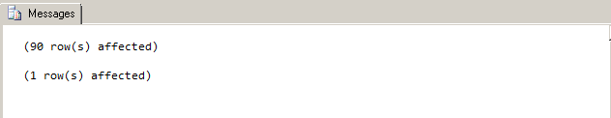
Results

Notes and Observations
- customers with orders and those without orders were selected with appropriate queries and their 'active' columns were updated with either a '0' or a '1' value.
2 Part B - SQL Statements

2.3 Part B Question 3
List all the orders where the order date is between January 1 and December 31, 2001. Display the order id, order date, and a new shipped date calculated by adding 7 days to the shipped date from the orders table, the product name from the product table, the customer name from the customer table, and the cost of the order. Format the date order date and the shipped date as MON DD YYYY. Use the formula (quantity * unit_price) to calculate the cost of the order. The query should produce the result set listed below.

order_id | product_name | customer_name | order_date | new_shipped_date | order_cost
10000 | Alice Mutton | Franchi S.p.A. | May 10 2001 | May 22 2001 | 156.0000
10001 | NuNuCa Nuß-Nougat-Crème Mère | Paillarde May | May 13 2001 | May 30 2001 | 420.0000
10001 | Boston Crab Meat | Mère Paillarde | May 13 2001 | May 30 2001 | 736.0000
10001 | Raclette Courdavault | Mère Paillarde | May 13 2001 | May 30 2001 | 440.0000
10001 | Wimmers gute Semmelknödel | Mère Paillarde | May 13 2001 | May 30 2001 | 498.7500
10138 | Inlagd Sill | Du monde entire | Dec 27 2001 | Jan 10 2002 | 228.0000
10138 | Louisiana Hot Spiced Okra | Du monde entire | Dec 27 2001 | Jan 10 2002 | 204.0000
10139 | Camembert Pierrot | Vaffeljernet | Dec 30 2001 | Jan 16 2002 | 680.0000
(383 row(s) affected)

2 Part B - SQL Statements

Query
SELECT 'order_id'=orders.order_id,
'product_name'=products.name,
'customer_name'=customers.name,
'order_date'= CONVERT(CHAR(11),orders.order_date,0),
'new_shipped_date'= CONVERT(CHAR(11),DATEADD(DAY,7,orders.order_date)),
'order_cost'= order_details.quantity*products.unit_price
FROM order_details
INNER JOIN orders ON order_details.order_id=orders.order_id
INNER JOIN products ON order_details.product_id=products.product_id
INNER JOIN customers ON orders.customer_id=customers.customer_id
WHERE orders.order_date BETWEEN 'January 1, 2001' AND 'December 31, 2001';

Results (rows 1 to 13 from 383 rows)
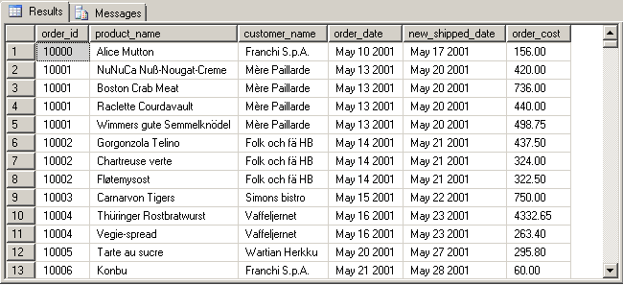
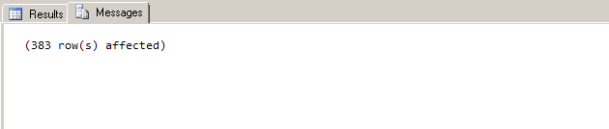
Notes and Observations
- Three inner joins are required to connect the tables order_details, orders, products and customers.
2 Part B - SQL Statements

2.4 Part B Question 4
List all the orders that have not been shipped. Display the customer id, name and phone number from the customers table, and the order id and order date from the orders table. Order the result set by the customer name. The query should produce the result set listed below. Your displayed results may look slightly different to those shown below but the query should still return 21 rows.

customer_id | Name | Phone | order_id | order_date
BLAUS | Blauer See Delikatessen | 0621-08460 | 11058 | 2004-03-23 00:00:00.000
BONAP | Bon app' | 91.24.45.40 | 11076 | 2004-03-30 00:00:00.000
ERNSH | Ernst Handel | 7675-3425 | 11008 | 2004-03-02 00:00:00.000
.....
RICAR | Ricardo Adocicados | (21) 555-3412 | 11059 | 2004-03-23 00:00:00.000
RICSU | Richter Supermarkt | 0897-034214 | 11075 | 2004-03-30 00:00:00.000
SIMOB | Simons bistro | 31 12 34 56 | 11074 | 2004-03-30 00:00:00.000
(21 row(s) affected)

Query

SELECT customers.customer_id,
customers.name,
customers.phone,
orders.order_id,
orders.order_date
FROM customers
INNER JOIN orders ON customers.customer_id=orders.customer_id
WHERE orders.shipped_date IS NULL
ORDER BY customers.name;

Notes and Observations
- “..have not been shipped” means records with a shipped_date field set to NULL, hence the query above.

2 Part B - SQL Statements

Results (rows 1 to 13 from 21 rows)
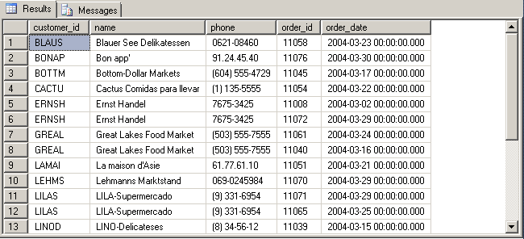
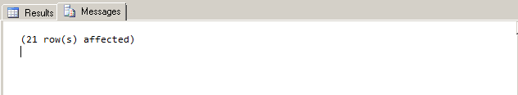

2 Part B - SQL Statements

2.5 Part B Question 5
List all the customers where the region is NULL. Display the customer id, name, and city from the customers table, and the title description from the titles table. The query should produce the result set listed below.

customer_id | Name | City | Description
ALFKI | Alfreds Futterkiste | Berlin | Sales Representative
ANATR | Ana Trujillo Emparedados y helados | México D.F. | Owner
ANTON | Antonio Moreno Taquería | México D.F. | Owner
AROUT | Around the Horn | London | Sales Representative
BERGS | Berglunds snabbköp | Luleå | Order Administrator
...
WARTH | Wartian Herkku | Oulu | Accounting Manager
WILMK | Wilman Kala | Helsinki | Owner/Marketing Assistant
WOLZA | Wolski Zajazd | Warszawa | Owner
(60 row(s) affected)

Query

SELECT customers.customer_id,
customers.name,
customers.city,
titles.description
FROM customers
INNER JOIN titles ON customers.title_id=titles.title_id
WHERE customers.region IS NULL;

2 Part B - SQL Statements

Results (1 to 13 of 60 rows)
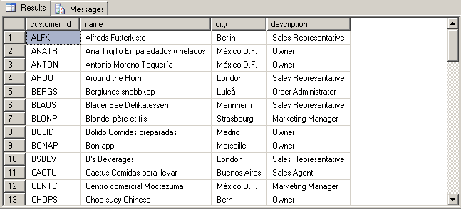
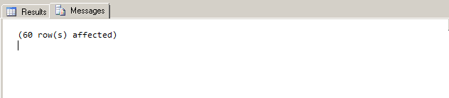

2 Part B - SQL Statements

2.6 Part B Question 6
List the products where the reorder level is higher than the quantity in stock. Display the supplier name from the suppliers table, the product name, reorder level, and quantity in stock from the products table. Order the result set by the supplier name. The query should produce the result set listed below.

supplier_name | product_name | reorder_level | quantity_in_stock
Armstrong Company | Queso Cabrales | 30 | 22
Cadbury Products Ltd. | Ipoh Coffee | 25 | 17
Cadbury Products Ltd. | Røgede sild | 15 | 5
Campbell Company | Gnocchi di nonna Alice | 30 | 21
Dare Manufacturer Ltd. | Gnocchi di nonna Alice | 15 | 6
...
Steveston Export Company | Gravad lax | 25 | 11
Steveston Export Company | Outback Lager | 30 | 15
Yves Delorme Ltd. | Longlife Tofu | 5 | 4
(18 row(s) affected)

Query

SELECT suppliers.name,
products.name,
products.reorder_level,
products.quantity_in_stock
FROM products
INNER JOIN suppliers ON products.supplier_id=suppliers.supplier_id
WHERE products.reorder_level>products.quantity_in_stock
ORDER BY suppliers.name;

2 Part B - SQL Statements

Results (rows 1 to 13 from 18 rows)
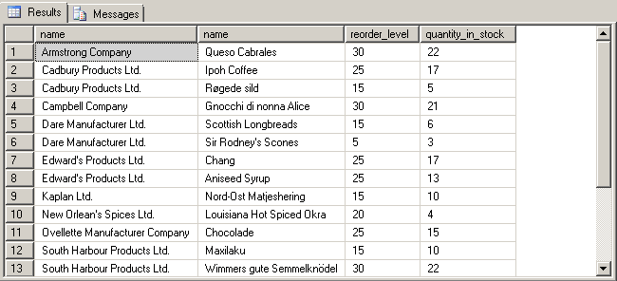
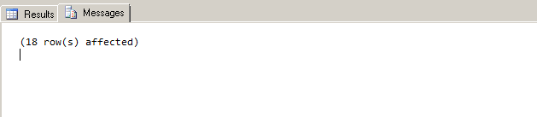

2 Part B - SQL Statements

2.7 Part B Question 7

Calculate the length in years from January 1, 2008 and when an order was shipped where the shipped date is not null. Display the order id, and the shipped date from the orders table, the customer name, and the contact name from the customers table, and the length in years for each order. Display the shipped date in the format MMM DD YYYY. Order the result set by order id and the calculated years. The query should produce the result set listed below.

order_id | name | contact_name | shipped_date | elapsed
10000 | Franchi S.p.A | Paolo Accorti | May 15 2001 | 7
10001 | Mère Paillarde | Jean Fresnière | May 23 2001 | 7
10002 | Folk och fä HB | Maria Larsson | May 17 2001 | 7
10003 | Simons bistro | Jytte Petersen | May 24 2001 | 7
10004 | Vaffeljernet | Palle Ibsen | May 20 2001 | 7
...
11066 | White Clover Markets | Karl Jablonski | Mar 28 2004 | 4
11067 | Drachenblut Delikatessen | Sven Ottlieb | Mar 30 2004 | 4
11069 | Tortuga Restaurante | Miguel Angel Paolino | Mar 30 2004 | 4
(1057 row(s) affected)

Query

SELECT orders.order_id,
customers.name,
customers.contact_name,
'shipped_date'=CONVERT(CHAR(11),orders.shipped_date, 100),
'elapsed'=DATEDIFF(YEAR, orders.shipped_date, 'January 1, 2008')
FROM orders
INNER JOIN customers ON orders.customer_id=customers.customer_id
WHERE orders.shipped_date IS NOT NULL
ORDER BY orders.order_id,'elapsed';

2 Part B - SQL Statements

Results (rows 1 to 13 from 1075 rows)
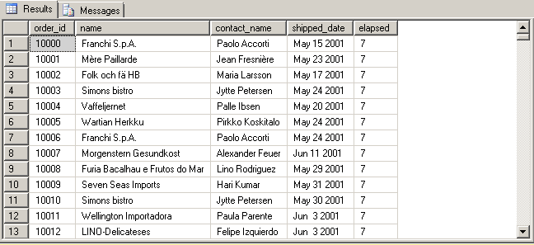
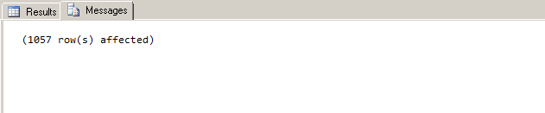

2 Part B - SQL Statements

2.8 Part B Question 8
List number of customers with names beginning with each letter of the alphabet. Ignore customers whose name begins with the letter S. Do not display the letter and count unless at least two customer’s names begin with the letter. The query should produce the result set listed below.

name | total
A | 4
B | 7
C | 5
D | 3
E | 2
...
T | 6
V | 3
W | 5
(17 row(s) affected)

Query

SELECT 'name'= SUBSTRING(name,1,1),
'total'=COUNT(name)
FROM customers
WHERE SUBSTRING(name,1,1) LIKE '[^S]'
GROUP BY SUBSTRING(name,1,1)
HAVING COUNT(name)>=2;

2 Part B - SQL Statements

Results (rows 1 to 13 from 17 rows)
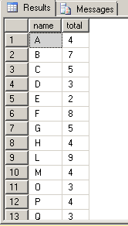

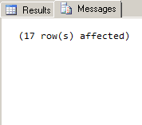

2 Part B - SQL Statements

2.9 Part B Question 9

List the order details where the quantity is greater than 100. Display the order id and
quantity from the order_details table, the product id and reorder level from the products table, and the supplier id from the suppliers table. Order the result set by the order id. The query should produce the result set listed below.

order_id | Quantity | product_id | reorder_level | supplier_id
10193 | 110 | 43 | 25 | 10
10226 | 110 | 29 | 0 | 12
10398 | 120 | 55 | 20 | 15
10451 | 120 | 55 | 20 | 15
10515 | 120 | 27 | 30 | 11
...
10895 | 110 | 24 | 0 | 10
11017 | 110 | 59 | 0 | 8
11072 | 130 | 64 | 30 | 12
(15 row(s) affected)

Query

SELECT order_details.order_id,
order_details.quantity,
products.product_id,
products.reorder_level,
suppliers.supplier_id
FROM order_details
INNER JOIN products ON order_details.product_id=products.product_id
INNER JOIN suppliers ON suppliers.supplier_id=products.supplier_id
WHERE order_details.quantity > 100
ORDER BY order_details.order_id;

2 Part B - SQL Statements

Results
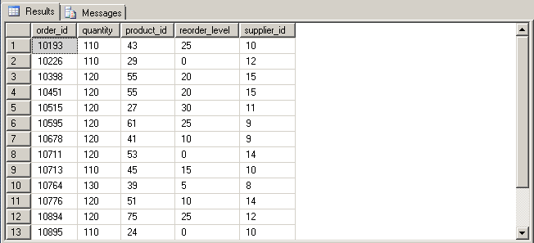
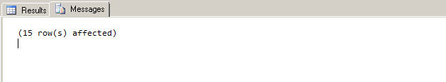

2 Part B - SQL Statements

2.10 Part B Question 10

List the products which contain tofu or chef in their name. Display the product id, product name, quantity per unit and unit price from the products table. Order the result set by product name. The query should produce the result set listed below.

product_id | Name | quantity_per_unit | unit_price
4 | Chef Anton's Cajon Seasoning | 48 – 6 oz jars | 22.0000
5 | Chef Anton's Gumbo Mix | 36 boxes | 21.3500
74 | Longlife Tofu | 5kg pkg. | 10.0000
14 | Tofu | 40-100g pkgs. | 23.2500
(4 row(s) affected)

Query

SELECT products.product_id,
products.name,
products.quantity_per_unit,
products.unit_price
FROM products
WHERE products.name LIKE '%tofu%'
UNION ALL
SELECT products.product_id,
products.name,
products.quantity_per_unit,
products.unit_price
FROM products
WHERE products.name LIKE '%chef%'
ORDER BY products.name;

Notes and Observations
- '%tofu%' and '%chef%' ensures matches anywhere within the field value.

2 Part B - SQL Statements

Results
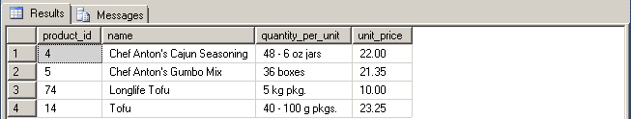
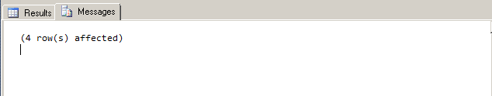

3 Part C - INSERT, UPDATE, DELETE and VIEWS Statements

3.1 Part C Question 1

Create an employee table with the following columns:

Column Name | Data Type | Length | Null values
employee_id | Int |  | No
last_name | varchar | 30 | No
first_name | varchar | 15 | No
address | varchar | 30
city | varchar | 20
province | char | 2
postal_code | varchar | 7
phone | varchar | 10
birth_date | datetime |  | No

Query

CREATE TABLE employee
(
employee_id int NOT NULL,
last_name VARCHAR(30) NOT NULL,
first_name VARCHAR(15) NOT NULL,
address VARCHAR(30),
city VARCHAR(20),
province CHAR(2),
postal_code VARCHAR(7),
phone VARCHAR(10),
birth_date datetime
);
GO

3 Part C - INSERT, UPDATE, DELETE and VIEWS Statements

3.2 Part C Question 2

The primary key for the employee table should be the employee id.

Query

ALTER TABLE employee
ADD PRIMARY KEY (employee_id);
GO

3.3 Part C Question 3

Load the data into the employee table using the employee.txt file; 9 rows. In addition, create the relationship to enforce referential integrity between the employee and orders tables.

Query

BULK INSERT employee
FROM 'C:\TextFiles\employee.txt'
WITH ( CODEPAGE=1252,
DATAFILETYPE = 'char',
FIELDTERMINATOR = '\t',
KEEPNULLS,
ROWTERMINATOR = '\n'
)
GO

ALTER TABLE orders
ADD CONSTRAINT FK_employee_orders FOREIGN KEY(employee_id)
REFERENCES employee(employee_id);
GO

3 Part C - INSERT, UPDATE, DELETE and VIEWS Statements

3.4 Part C Question 4

Using the INSERT statement, add the shipper Quick Express to the shippers table.

Query

INSERT INTO shippers
VALUES ('Quick Express');
GO

SELECT *
FROM shippers;

Result

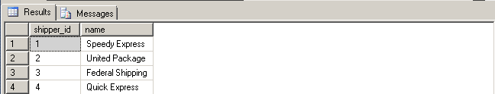
Notes and Observations
- A shipper_id is assigned automatically for the new record without specifying it.

3 Part C - INSERT, UPDATE, DELETE and VIEWS Statements

3.5 Part C Question 5

Using the UPDATE statement, increase the unit price in the products table of all rows with a current unit price between $5.00 and $10.00 by 5%; 12 rows affected.

Query

UPDATE products
SET unit_price=unit_price*1.05
WHERE unit_price>=5 AND unit_price<=10;
GO

Results
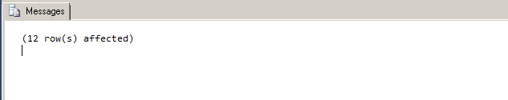
Notes and Observations
- Had the WHERE clause been forgotten, all records in the table would be updated.

3 Part C - INSERT, UPDATE, DELETE and VIEWS Statements

3.6 Part C Question 6

Using the UPDATE statement, change the fax value to Unknown for all rows in the customers table where the current fax value is NULL; 22 rows affected.

Query

UPDATE customers
SET fax='Unknown'
WHERE fax IS NULL;
GO

Result
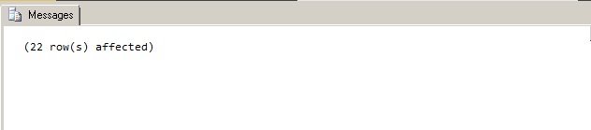

3 Part C - INSERT, UPDATE, DELETE and VIEWS Statements

3.7 Part C Question 7

Create a view called vw_order_cost to list the cost of the orders. Display the order id and order_date from the orders table, the product id from the products table, the customer name from the customers tble, and the order cost. To calculate the cost of the orders, use the formula (order_details.quantity * products.unit_price). Run the view for the order ids between 10000 and 10200. The view should produce the result set listed below.

order_id | order_date | product_id | name | order_cost
10000 | 2001-05-10 00:00:00.000 | 17 | Franchi S.p.A | 156.0000
10001 | 2001-05-13 00:00:00.000 | 25 | Mère Paillarde | 420.0000
10001 | 2001-05-13 00:00:00.000 | 40 | Mère Paillarde | 736.0000
10001 | 2001-05-13 00:00:00.000 | 59 | Mère Paillarde | 440.0000
10001 | 2001-05-13 00:00:00.000 | 64 | Mère Paillarde | 498.7500
...
10199 | 2002-03-27 00:00:00.000 | 3 | Save-a-lot Markets | 400.0000
10199 | 2002-03-27 00:00:00.000 | 39 | Save-a-lot Markets | 720.0000
10200 | 2002-03-30 00:00:00.000 | 11 | Comidas preparadas 588.0000 | 588.0000
(540 row(s) affected)

Query

CREATE VIEW vw_order_cost(order_id, order_date, product_id, name, order_cost)
AS
SELECT orders.order_id,
orders.order_date,
products.product_id,
customers.name,
'order_cost'=order_details.quantity*products.unit_price
FROM order_details
INNER JOIN orders ON order_details.order_id=orders.order_id
INNER JOIN products ON order_details.product_id=products.product_id
INNER JOIN customers ON orders.customer_id=customers.customer_id
GO

SELECT order_id,
order_date,
product_id,
3 Part C - INSERT, UPDATE, DELETE and VIEWS Statements

name,
order_cost
FROM vw_order_cost
WHERE order_id BETWEEN 10000 AND 10200;
GO

Result (rows 1 to 12 from 540 rows)

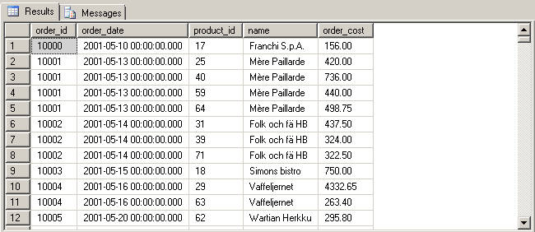
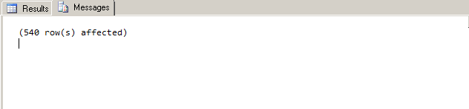

3 Part C - INSERT, UPDATE, DELETE and VIEWS Statements

3.8 Part C Question 8

Create a view called vw_list_employees to list all the employees and all the columns in the employee table. Run the view for employee ids 5, 7, and 9. Display the employee id, last name, first name, and birth date. Format the name as last name followed by a comma and a space followed by the first name. Format the birth date as YYYY.MM.DD. The view should produce the result set listed below.

employee_id | Name | birth_date
5 | Buchanan, Steven | 1955.03.04
7 | King, Robert | 1960.05.29
9 | Dodsworth, Anne | 1966.01.27
(3 row(s) affected)

Query

CREATE VIEW vw_list_employees (employee_id, name, birth_date)
AS
SELECT employee.employee_id,
employee.last_name+', '+employee.first_name,
CONVERT(CHAR(10),employee.birth_date,102)
FROM employee
GO

SELECT employee_id,
name,
birth_date
FROM vw_list_employees
WHERE employee_id IN (5,7,9);
GO

3 Part C - INSERT, UPDATE, DELETE and VIEWS Statements

Results

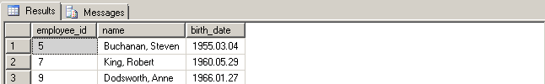
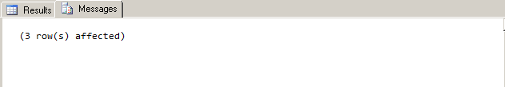

3 Part C - INSERT, UPDATE, DELETE and VIEWS Statements

3.9 Part C Question 9

Create a view called vw_all_orders to list all the orders. Display the order id and shipped date from the orders table, and the customer id, name, city, and country from the customers table. Run the view for orders shipped from January 1, 2002 and December 31, 2002, formatting the shipped date as MON DD YYYY. Order the result set by customer name and country. The view should produce the result set listed below.

order_id | customer_id | customer_name | city | country | shipped_date
10308 | ANATR | Ana Trujillo Emparedados y helados | México D.F. | Mexico | Aug 18 2002
10365 | ANTON | Antonio Moreno Taquería | México D.F. | Mexico | Oct 26 2002
10137 | ANTON | Antonio Moreno Taquería | México D.F. | Mexico | Jan 22 2002
10142 | ANTON | Antonio Moreno Taquería | México D.F. | Mexico | Jan 8 2002
10218 | ANTON | Antonio Moreno Taquería | México D.F. | Mexico | May 25 2002
...
10344 | WHITC | White Clover Markets | Seattle | United States | Sep 29 2002
10269 | WHITC | White Clover Markets | Seattle | United States | Jul 3 2002
10374 | WOLZA | Wolski Zajazd | Warszawa | Poland | Nov 2 2002
(293 row(s) affected

Query

CREATE VIEW vw_all_orders (order_id, customer_id, customer_name, city, country, shipped_date) /* CREATE VIEW cannot be combined with other statements in batch */
AS
SELECT orders.order_id,
customers.customer_id,
customers.name,
customers.city,
customers.country,
orders.shipped_date
FROM orders
3 Part C - INSERT, UPDATE, DELETE and VIEWS Statements

INNER JOIN customers ON orders.customer_id=customers.customer_id;
GO

SELECT order_id,
customer_id,
customer_name,
city,
country,
'shipped_date'= CONVERT(CHAR(11),shipped_date,100)
FROM vw_all_orders
WHERE shipped_date BETWEEN 'January 1, 2002' AND 'December 31, 2002'
ORDER BY customer_name, country;
GO

Result (rows 1 to 12 from 293 rows)

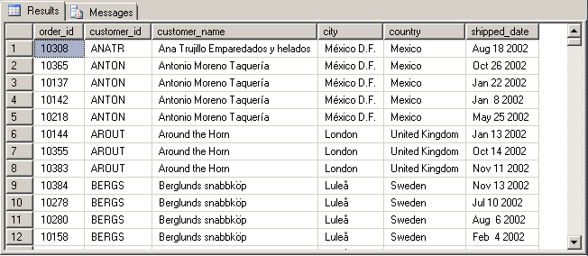
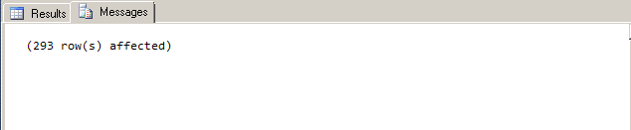

3 Part C - INSERT, UPDATE, DELETE and VIEWS Statements

3.10 Part C Question 10

Create a view listing the suppliers and the items they have shipped. Display the supplier id and name from the suppliers table, and the product id and name from the products table. Run the view. The view should produce the result set listed below, although not necessarily in the same order.

supplier_id | supplier_name | product_id | product_name
9 | Silver Spring Wholesale Market | 23 | Tunnbröd
11 | Ovellette Manufacturer Company | 46 | Spegesild
15 | Campbell Company | 69 | Gudbrandsdalsost
12 | South Harbour Products Ltd. | 77 | Original Frankfurter grüne Soße
14 | St. Jean's Company | 31 | Gorgonzola Telino
...
7 | Steveston Export Company | 63 | Vegie-spread
3 | Macaulay Products Company | 8 | Northwoods Cranberry Sauce
15 | Campbell Company | 55 | Pâté chinois
(77 row(s) affected)

Query

CREATE VIEW vw_product_by_supplier (supplier_id,supplier_name,product_id,product_name)
AS
SELECT suppliers.supplier_id,
suppliers.name,
products.product_id,
products.name
FROM products
INNER JOIN suppliers ON products.supplier_id=suppliers.supplier_id
GO

SELECT supplier_id,
supplier_name,
product_id,
product_name
3 Part C - INSERT, UPDATE, DELETE and VIEWS Statements

FROM vw_product_by_supplier;
GO

Notes and Observations
- Assigning the VIEW its own field names is redundant as it inherits the names anyway if not provided.

Result (rows 1 to 12 of 77)
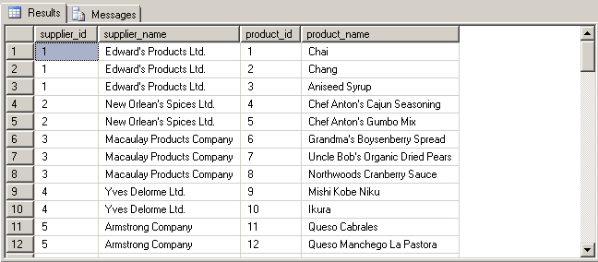

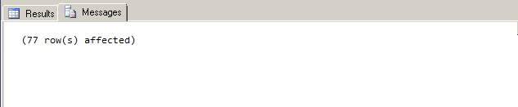

4 Part D - Stored Procedures and Triggers

4.1 Part D Question 1

Create a stored procedure called sp_customer_city displaying the customers living in a particular city. The city will be an input parameter for the stored procedure. Display the customer id, name, address, city and phone from the customers table. Run the stored procedure displaying customers living in London. The stored procedure should produce the result set listed below.

customer_id | name | address | city | phone
AROUT | Around the Horn | 120 Hanover Sq. | London | (71) 555-7788
BSBEV | B's Beverages | Fauntleroy Circus | London | (71) 555-1212
CONSH | Consolidated Holdings | Berkeley Gardens 12 Brewery | London | (71) 555-2282
EASTC | Eastern Connection | 35 King George | London | (71) 555-0297
NORTS | North/South | South House 300 Queensbridge | London | (71) 555-7733
SEVES | Seven Seas Imports | 90 Wadhurst Rd. | London | (71) 555-1717
(6 row(s) affected)

Query

CREATE PROCEDURE sp_customer_city
(
@city varchar(30)
)
AS
SELECT customer_id,
name,
address,
city,
phone
FROM customers
WHERE city=@city
GO

EXECUTE sp_customer_city 'London';
GO

4 Part D - Stored Procedures and Triggers

Result
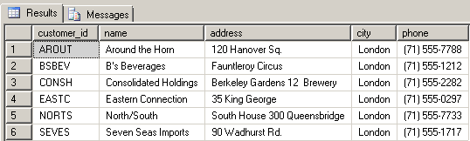
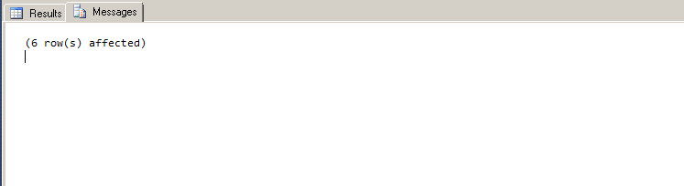

4 Part D - Stored Procedures and Triggers

4.2 Part D Question 2

Create a stored procedure called sp_orders_by_dates displaying the orders shipped between particular dates. The start and end date will be input parameters for the stored procedure. Display the order id, customer id, and shipped date from the orders table, the customer name from the customer table, and the shipper name from the shippers table. Run the stored procedure displaying orders from January 1, 2003 to June 30, 2003. The stored procedure should produce the result set listed below.

order_id | customer_id | customer_name | shipper_name | shipped_date
10423 | GOURL | Gourmet Lanchonetes | Federal Shipping | 2003-01-18 00:00:00.000
10425 | LAMAI | La maison d'Asie | United Package | 2003-01-08 00:00:00.000
10427 | PICCO | Piccolo und mehr | United Package | 2003-01-25 00:00:00.000
10429 | HUNGO | Hungry Owl All-Night Grocers | United Package | 2003-01-01 00:00:00.000
10431 | BOTTM | Bottom-Dollar Markets | United Package | 2003-01-01 00:00:00.000
...
10615 | WILMK | Wilman Kala | Federal Shipping | 2003-06-30 00:00:00.000
10616 | GREAL | Great Lakes Food Market | United Package | 2003-06-29 00:00:00.000
10617 | GREAL | Great Lakes Food Market | United Package | 2003-06-28 00:00:00.000
(188 row(s) affected)

Query

CREATE PROCEDURE sp_orders_by_dates
(
@start VARCHAR(30),
@end VARCHAR(30)
)
AS
SELECT orders.order_id,
orders.customer_id,
'customer_name'=customers.name,
'shipper_name'=shippers.name,
orders.shipped_date
FROM orders
INNER JOIN customers ON orders.customer_id=customers.customer_id
INNER JOIN shippers ON orders.shipper_id=shippers.shipper_id
WHERE orders.shipped_date BETWEEN @start AND @end;
4 Part D - Stored Procedures and Triggers

GO

EXECUTE sp_orders_by_dates 'January 1, 2003', 'June 30, 2003';
GO

Notes and Observations
- SQL appears to be flexible about inputs of the type VARCHAR for searches with regards to date.

Results (rows 1 to 14 of 188 rows)

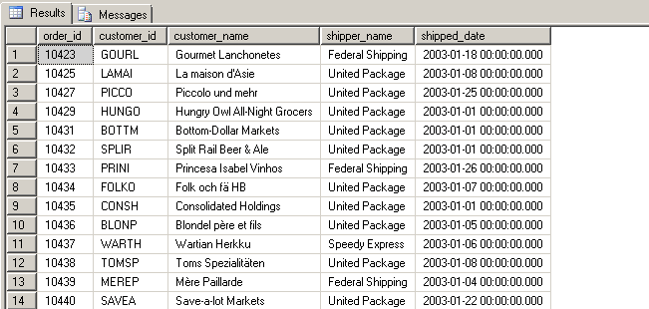
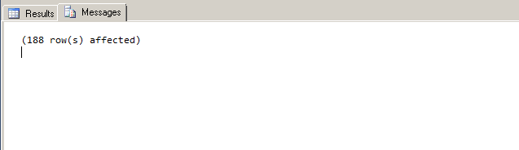

4 Part D - Stored Procedures and Triggers

4.3 Part D Question 3

Create a stored procedure called sp_product_listing listing a specified product ordered
during a specified month and year. The product and the month and year will be input
parameters for the stored procedure. Display the product name, unit price, and quantity in stock from the products table, and the supplier name from the suppliers table. Run the stored procedure displaying a product name containing Jack and the month of the order date is June and the year is 2001. The stored procedure should produce the result set listed below.

product_name | unit_price | quantity_in_stock | supplier_name
Jack's New England Clam Chowder | 10.1325 | 85 | Silver Spring Wholesale Market
Jack's New England Clam Chowder | 10.1325 | 85 | Silver Spring Wholesale Market
Jack's New England Clam Chowder | 10.1325 | 85 | Silver Spring Wholesale Market
Jack's New England Clam Chowder | 10.1325 | 85 | Silver Spring Wholesale Market
(4 row(s) affected)

Query

CREATE PROCEDURE sp_product_listing
(
@product VARCHAR(30),
@month VARCHAR(10),
@year VARCHAR(10)
)
AS
SELECT 'product_name'=products.name,
products.unit_price,
products.quantity_in_stock,
suppliers.name
FROM products
INNER JOIN suppliers ON products.supplier_id=suppliers.supplier_id
INNER JOIN order_details ON products.product_id=order_details.product_id
INNER JOIN orders ON order_details.order_id=orders.order_id
WHERE products.name LIKE @product AND DATENAME(month,orders.order_date)=@month AND DATEPART(year, orders.order_date)=@year;
GO
EXECUTE sp_product_listing '%Jack%','June', 2001;
GO
4 Part D - Stored Procedures and Triggers

Results
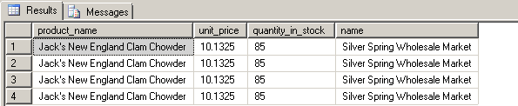
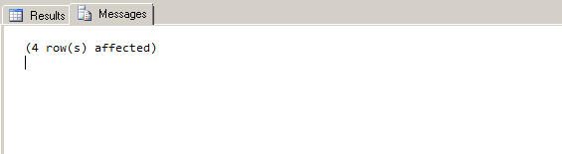

4 Part D - Stored Procedures and Triggers

4.4 Part D Question 4

Create a DELETE trigger called tr_delete_orders on the orders table to display an error message if an order is deleted that has a value in the order_details table. ( Since Referential Integrity constraints will normally prevent such deletions, this trigger needs to be an Instead of trigger.) Run the following query to verify your trigger.

DELETE orders
WHERE order_id = 10000

Query

CREATE TRIGGER tr_delete_orders
ON orders
INSTEAD OF DELETE
AS
DECLARE @testid VARCHAR(15)
SELECT @testid=order_id
FROM DELETED;
IF EXISTS
(
SELECT order_details.order_id
FROM order_details
WHERE order_details.order_id=@testid
)
BEGIN
PRINT 'Referential integrity violation. Cannot delete order.'
ROLLBACK TRANSACTION
END;
GO

DELETE orders
WHERE order_id=10000;
GO

Results
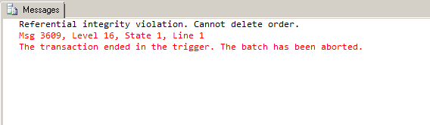

4 Part D - Stored Procedures and Triggers

4.5 Part D Question 5

Create an INSERT and UPDATE trigger called tr_check_qty on the order_details table to only allow orders of products that have a quantity in stock greater than or equal to the units ordered. Run the following query to verify your trigger.

UPDATE order_details
SET quantity = 30
WHERE order_id = '10044'
AND product_id = 7

Query

CREATE TRIGGER tr_check_qty
ON order_details
FOR INSERT, UPDATE
AS
IF EXISTS
(
SELECT
order_id
FROM INSERTED
INNER JOIN products ON INSERTED.product_id=products.product_id
WHERE INSERTED.quantity < products.quantity_in_stock
)
BEGIN
PRINT 'Only orders of products that have a quantity in stock greater than or equal to the units ordered are allowed.'
ROLLBACK TRANSACTION
END;
GO

UPDATE order_details
SET quantity=30
WHERE order_id='10044';
GO

Result
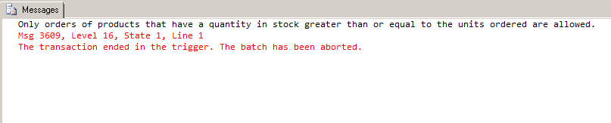

4 Part D - Stored Procedures and Triggers

4.6 Part D Question 6

Create a stored procedure called sp_del_inactive_cust to delete customers that have no orders. The stored procedure should delete 1 row.

Query

CREATE PROCEDURE sp_del_inactive_cust
AS
DELETE FROM customers
WHERE active=0;
GO

EXECUTE sp_del_inactive_cust;
GO

Result

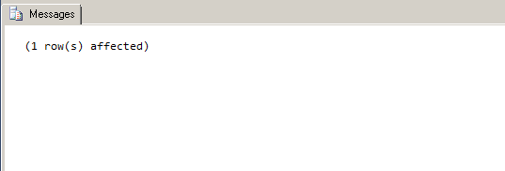
Notes and Observations
- Back in 2.2, customers with no orders were given “0” as the “active” value

4 Part D - Stored Procedures and Triggers

4.7 Part D Question 7

Create a stored procedure called sp_employee_information to display the employee
information for a particular employee. The employee id will be an input parameter for the stored procedure. Run the stored procedure displaying information for employee id of 5. The stored procedure should produce the result set listed below.

employee_id | last_name | first_name | address | city | province | postal_code | phone | birth_date
5 | Buchanan | Steven | 14 Garrett Hill | New Westminster | BC | V1G 8J7 | 6045554848 | 1955-03-04
(1 row(s) affected)

Query

CREATE PROCEDURE sp_employee_information
(
@emp_id_input VARCHAR(15)
)
AS
SELECT employee_id,
last_name,
first_name,
address,
city,
province,
postal_code,
phone,
birth_date
FROM employee
WHERE employee_id=@emp_id_input
GO

EXECUTE sp_employee_information 5;
GO

Result
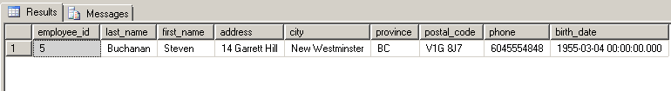
4 Part D - Stored Procedures and Triggers

4.8 Part D Question 8

Create a stored procedure called sp_reorder_qty to show when the reorder level subtracted from the quantity in stock is less than a specified value. The unit value will be an input parameter for the stored procedure. Display the product id, quantity in stock, and reorder level from the products table, and the supplier name, address, city, and province from the suppliers table. Run the stored procedure displaying the information for a value of 5. The stored procedure should produce the result set listed below.

product_id | name | address | city | province | qty | reorder_level
2 | Edward's Products Ltd. | 1125 Howe Street | Vancouver | BC | 17 | 25
3 | Edward's Products Ltd. | 1125 Howe Street | Vancouver | BC | 13 | 25
5 | New Orlean's Spices Ltd. | 1040 Georgia Street | West Vancouver | BC | 0 | 0
11 | Armstrong Company | 1638 Derwent Way | Richmond | BC | 22 | 30
17 | Steveston Export Company | 2951 Moncton Street | Richmond | BC | 0 | 0
...
68 | Dare Manufacturer Ltd. | 1603 3rd Avenue | West Burnaby | BC | 6 | 15
70 | Steveston Export Company | 2951 Moncton Street | Richmond | BC | 15 | 30
74 | Yves Delorme Ltd. | 3050 Granville Street | New Westminster | BC | 4 | 5
(23 row(s) affected)

4 Part D - Stored Procedures and Triggers

Query

CREATE PROCEDURE sp_reorder_qty
(
@unit int
)
AS
SELECT products.product_id,
suppliers.name,
suppliers.address,
suppliers.city,
suppliers.province,
'qty'=products.quantity_in_stock,
products.reorder_level
FROM products
INNER JOIN suppliers ON products.supplier_id=suppliers.supplier_id
WHERE products.quantity_in_stock-products.reorder_level < @unit
GO

EXECUTE sp_reorder_qty 5;
GO

Results (rows 1 to 20 of 23)
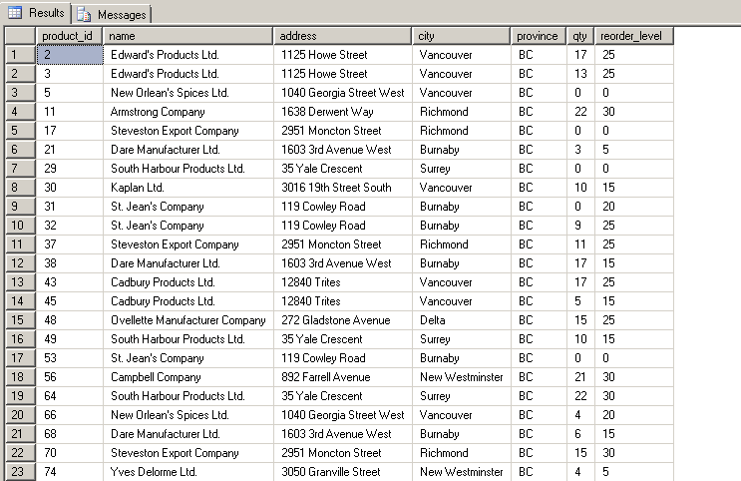
4 Part D - Stored Procedures and Triggers

4.9 Part D Question 9

Create a stored procedure called sp_unit_prices for the product table where the unit price is between particular values. The two unit prices will be input parameters for the stored procedure. Display the product id, product name, alternate name, and unit price from the products table. Run the stored procedure to display products where the unit price is between $5.00 and $10.00. The stored procedure should produce the result set listed below.

product_id | name | alternate_name | unit_price
13 | Konbu | Kelp Seaweed | 6.30
19 | Teatime Chocolate Biscuits | Teatime Chocolate Biscuits | 9.66
23 | Tunnbr÷d | Thin Bread | 9.45
45 | R°gede sild | Smoked Herring | 9.975
47 | Zaanse koeken | Zaanse Cookies | 9.975
52 | Filo Mix | Mix for Greek Filo Dough | 7.35
54 | TourtiÞre | Pork Pie | 7.8225
75 | Rh÷nbrõu Klosterbier | Rh÷nbrõu Beer | 8.1375
(8 row(s) affected)

Query

CREATE PROCEDURE sp_unit_prices
(
@unit_price_low_end VARCHAR(15),
@unit_price_high_end VARCHAR(15)
)
AS
SELECT product_id,
name,
alternate_name,
unit_price
FROM products
WHERE unit_price BETWEEN @unit_price_low_end AND @unit_price_high_end
GO

EXECUTE sp_unit_prices 5, 10;

4 Part D - Stored Procedures and Triggers

Results

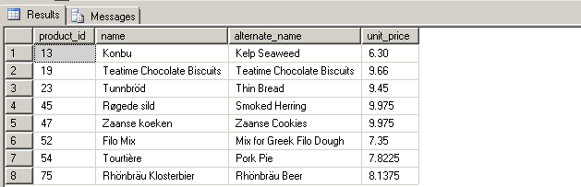

5 Query file

/****** Drop previous database ******/

USE master; --select master which has all the databases
GO

IF EXISTS --checking for the existence of 'Cus_Orders' database and deletes it if found
(
SELECT *
FROM sysdatabases
WHERE name='Cus_Orders'
)
BEGIN
PRINT('Dropping database...')
DROP DATABASE Cus_Orders;
END
GO

/****** PART A ********/

USE master;
GO

/*#1*/

CREATE DATABASE Cus_Orders;
GO

USE Cus_Orders;
GO

/*#2*/

CREATE TYPE uniqid FROM CHAR(5) NOT NULL;
CREATE TYPE intid FROM int NOT NULL;
GO

/*#3*/
/* TABLE CREATION */

CREATE TABLE customers
(
customer_id uniqid,
name VARCHAR(50),
contact_name VARCHAR(30),
title_id CHAR(3) NOT NULL,
address VARCHAR(50),
city VARCHAR(20),
region VARCHAR(15),
country_code VARCHAR(10),
country VARCHAR(15),
phone VARCHAR(20),
5 Query file

fax VARCHAR(20)
);

CREATE TABLE orders
(
order_id intid,
customer_id uniqid,
employee_id int NOT NULL,
shipping_name VARCHAR(50),
shipping_address VARCHAR(50),
shipping_city VARCHAR(20),
shipping_region VARCHAR(15),
shipping_country_code VARCHAR(10),
shipping_country VARCHAR(15),
shipper_id int NOT NULL,
order_date datetime,
required_date datetime,
shipped_date datetime,
freight_charge money
);

CREATE TABLE order_details
(
order_id intid,
product_id intid,
quantity int NOT NULL,
discount float NOT NULL
);

CREATE TABLE products
(
product_id intid,
supplier_id int NOT NULL,
name VARCHAR(40),
alternate_name VARCHAR(40),
quantity_per_unit VARCHAR(25),
unit_price money,
quantity_in_stock int,
units_on_stock int,
reorder_level int
);

CREATE TABLE shippers
(
shipper_id int IDENTITY(1,1) NOT NULL,
name VARCHAR(20) NOT NULL
);

CREATE TABLE suppliers
(
supplier_id int IDENTITY(1,1) NOT NULL,
name VARCHAR(40) NOT NULL,
address VARCHAR(30),
city VARCHAR(20),
province CHAR(2)
5 Query file

);

CREATE TABLE titles
(
title_id char(3) NOT NULL,
description VARCHAR(35) NOT NULL
);
GO

/*#4*/
/*CREATE PK's*/

ALTER TABLE customers
ADD PRIMARY KEY (customer_id);
GO

ALTER TABLE orders
ADD PRIMARY KEY (order_id);
GO

ALTER TABLE order_details
ADD PRIMARY KEY (order_id, product_id);
GO

ALTER TABLE products
ADD PRIMARY KEY (product_id);
GO

ALTER TABLE shippers
ADD PRIMARY KEY (shipper_id);
GO

ALTER TABLE suppliers
ADD PRIMARY KEY (supplier_id);
GO

ALTER TABLE titles
ADD PRIMARY KEY (title_id);
GO

/* ADD FK's */

ALTER TABLE orders
ADD CONSTRAINT FK_customers_orders FOREIGN KEY(customer_id)
REFERENCES customers(customer_id);
GO

ALTER TABLE orders
ADD CONSTRAINT FK_shippers_orders FOREIGN KEY(shipper_id)
REFERENCES shippers(shipper_id);
GO

ALTER TABLE order_details
ADD CONSTRAINT FK_orders_order_details FOREIGN KEY(order_id)
5 Query file

REFERENCES orders(order_id);
GO

ALTER TABLE order_details
ADD CONSTRAINT FK_products_order_details FOREIGN KEY(product_id)
REFERENCES products(product_id);
GO

ALTER TABLE products
ADD CONSTRAINT FK_suppliers_products FOREIGN KEY(supplier_id)
REFERENCES suppliers(supplier_id);
GO

ALTER TABLE customers
ADD CONSTRAINT FK_titles_customers FOREIGN KEY(title_id)
REFERENCES titles(title_id);
GO

/*#5*/
/* Other constraints */

ALTER TABLE customers
ADD CONSTRAINT default_country
DEFAULT('Canada') FOR country;
GO

ALTER TABLE orders
ADD CONSTRAINT default_date
DEFAULT(DATEADD(DAY,10,GETDATE())) FOR order_date;
GO

ALTER TABLE order_details
ADD CONSTRAINT check_ord_quantity
CHECK(quantity>=1);
GO

ALTER TABLE products
ADD CONSTRAINT check_reorder_level
CHECK(reorder_level >=1);
GO

ALTER TABLE products
ADD CONSTRAINT check_quantity_in_stock
CHECK(quantity_in_stock <=150);
GO

ALTER TABLE suppliers
ADD CONSTRAINT default_province
DEFAULT('BC') FOR province;
GO

/*#6*/
/* Load data into tables */

5 Query file

BULK INSERT titles
FROM 'C:\TextFiles\titles.txt'
WITH (
CODEPAGE=1252,
DATAFILETYPE = 'char',
FIELDTERMINATOR = '\t',
KEEPNULLS,
ROWTERMINATOR = '\n'
)

BULK INSERT suppliers
FROM 'C:\TextFiles\suppliers.txt'
WITH (
CODEPAGE=1252,
DATAFILETYPE = 'char',
FIELDTERMINATOR = '\t',
KEEPNULLS,
ROWTERMINATOR = '\n'
)

BULK INSERT shippers
FROM 'C:\TextFiles\shippers.txt'
WITH (
CODEPAGE=1252,
DATAFILETYPE = 'char',
FIELDTERMINATOR = '\t',
KEEPNULLS,
ROWTERMINATOR = '\n'
)

BULK INSERT customers
FROM 'C:\TextFiles\customers.txt'
WITH (
CODEPAGE=1252,
DATAFILETYPE = 'char',
FIELDTERMINATOR = '\t',
KEEPNULLS,
ROWTERMINATOR = '\n'
)

BULK INSERT products
FROM 'C:\TextFiles\products.txt'
WITH (
CODEPAGE=1252,
DATAFILETYPE = 'char',
FIELDTERMINATOR = '\t',
KEEPNULLS,
ROWTERMINATOR = '\n'
)

BULK INSERT order_details
FROM 'C:\TextFiles\order_details.txt'
WITH (
CODEPAGE=1252,
5 Query file

DATAFILETYPE = 'char',
FIELDTERMINATOR = '\t',
KEEPNULLS,
ROWTERMINATOR = '\n'
)

BULK INSERT orders
FROM 'C:\TextFiles\orders.txt'
WITH (
CODEPAGE=1252,
DATAFILETYPE = 'char',
FIELDTERMINATOR = '\t',
KEEPNULLS,
ROWTERMINATOR = '\n'
)
GO

/********** PART B ************/

/*#1*/
SELECT customer_id, name, city, country
FROM customers
ORDER BY customer_id;

/*#2*/
ALTER TABLE customers
ADD active bit;
GO

ALTER TABLE customers
ADD CONSTRAINT default_active
DEFAULT (1) FOR active;
GO

UPDATE customers
SET active=1
WHERE EXISTS
(
SELECT *
FROM orders
WHERE orders.customer_id=customers.customer_id
)
GO

UPDATE customers
SET active=0
WHERE NOT EXISTS
(
SELECT *
FROM orders
WHERE orders.customer_id=customers.customer_id
)
GO
5 Query file

/*#3*/

SELECT 'order_id'=orders.order_id,
'product_name'=products.name,
'customer_name'=customers.name,
'order_date'= CONVERT(CHAR(11),orders.order_date,0),
'new_shipped_date'= CONVERT(CHAR(11),DATEADD(DAY,7,orders.order_date)),
'order_cost'= order_details.quantity*products.unit_price
FROM order_details
INNER JOIN orders ON order_details.order_id=orders.order_id
INNER JOIN products ON order_details.product_id=products.product_id
INNER JOIN customers ON orders.customer_id=customers.customer_id
WHERE orders.order_date BETWEEN 'January 1, 2001' AND 'December 31, 2001';

/*#4*/

SELECT customers.customer_id,
customers.name,
customers.phone,
orders.order_id,
orders.order_date
FROM customers
INNER JOIN orders ON customers.customer_id=orders.customer_id
WHERE orders.shipped_date IS NULL
ORDER BY customers.name;

/*#5*/

SELECT customers.customer_id,
customers.name,
customers.city,
titles.description
FROM customers
INNER JOIN titles ON customers.title_id=titles.title_id
WHERE customers.region IS NULL;

/*#6*/

SELECT suppliers.name,
products.name,
products.reorder_level,
products.quantity_in_stock
FROM products
INNER JOIN suppliers ON products.supplier_id=suppliers.supplier_id
WHERE products.reorder_level>products.quantity_in_stock
ORDER BY suppliers.name;

/*#7*/

SELECT orders.order_id,
customers.name,
customers.contact_name,
'shipped_date'=CONVERT(CHAR(11),orders.shipped_date, 100),
'elapsed'=DATEDIFF(YEAR, orders.shipped_date, 'January 1, 2008')
5 Query file

FROM orders
INNER JOIN customers ON orders.customer_id=customers.customer_id
WHERE orders.shipped_date IS NOT NULL
ORDER BY orders.order_id,'elapsed';

/*#8*/

SELECT 'name'= SUBSTRING(name,1,1),
'total'=COUNT(name)
FROM customers
WHERE SUBSTRING(name,1,1) LIKE '[^S]'
GROUP BY SUBSTRING(name,1,1)
HAVING COUNT(name)>=2;

/*#9*/

SELECT order_details.order_id,
order_details.quantity,
products.product_id,
products.reorder_level,
suppliers.supplier_id
FROM order_details
INNER JOIN products ON order_details.product_id=products.product_id
INNER JOIN suppliers ON suppliers.supplier_id=products.supplier_id
WHERE order_details.quantity > 100
ORDER BY order_details.order_id;

/*#10*/

SELECT products.product_id,
products.name,
products.quantity_per_unit,
products.unit_price
FROM products
WHERE products.name LIKE '%tofu%'
UNION ALL
SELECT products.product_id,
products.name,
products.quantity_per_unit,
products.unit_price
FROM products
WHERE products.name LIKE '%chef%'
ORDER BY products.name;

/******** PART C ************/

/*#1*/

CREATE TABLE employee
(
employee_id int NOT NULL,
last_name VARCHAR(30) NOT NULL,
first_name VARCHAR(15) NOT NULL,
address VARCHAR(30),
city VARCHAR(20),
5 Query file

province CHAR(2),
postal_code VARCHAR(7),
phone VARCHAR(10),
birth_date datetime
);
GO

/*#2*/

ALTER TABLE employee
ADD PRIMARY KEY (employee_id);
GO

/*#3*/

BULK INSERT employee
FROM 'C:\TextFiles\employee.txt'
WITH ( CODEPAGE=1252,
DATAFILETYPE = 'char',
FIELDTERMINATOR = '\t',
KEEPNULLS,
ROWTERMINATOR = '\n'
)
GO

ALTER TABLE orders
ADD CONSTRAINT FK_employee_orders FOREIGN KEY(employee_id)
REFERENCES employee(employee_id);
GO

/*#4*/

INSERT INTO shippers
VALUES ('Quick Express');
GO

SELECT *
FROM shippers;

/*#5*/

UPDATE products
SET unit_price=unit_price*1.05
WHERE unit_price>=5 AND unit_price<=10;
GO

/*#6*/

UPDATE customers
SET fax='Unknown'
WHERE fax IS NULL;
GO

/*#7*/
5 Query file

CREATE VIEW vw_order_cost(order_id, order_date, product_id, name, order_cost)
AS
SELECT orders.order_id,
orders.order_date,
products.product_id,
customers.name,
'order_cost'=order_details.quantity*products.unit_price
FROM order_details
INNER JOIN orders ON order_details.order_id=orders.order_id
INNER JOIN products ON order_details.product_id=products.product_id
INNER JOIN customers ON orders.customer_id=customers.customer_id
GO

SELECT order_id,
order_date,
product_id,
name,
order_cost
FROM vw_order_cost
WHERE order_id BETWEEN 10000 AND 10200;
GO

/*#8*/

CREATE VIEW vw_list_employees (employee_id, name, birth_date)
AS
SELECT employee.employee_id,
employee.last_name+', '+employee.first_name,
CONVERT(CHAR(10),employee.birth_date,102)
FROM employee
GO

SELECT employee_id,
name,
birth_date
FROM vw_list_employees
WHERE employee_id IN (5,7,9);
GO

/*#9*/

CREATE VIEW vw_all_orders (order_id, customer_id, customer_name, city, country, shipped_date) /* CREATE VIEW cannot be combined with other statements in batch */
AS
SELECT orders.order_id,
customers.customer_id,
customers.name,
customers.city,
customers.country,
orders.shipped_date
FROM orders
INNER JOIN customers ON orders.customer_id=customers.customer_id;
5 Query file

GO

SELECT order_id,
customer_id,
customer_name,
city,
country,
'shipped_date'= CONVERT(CHAR(11),shipped_date,100)
FROM vw_all_orders
WHERE shipped_date BETWEEN 'January 1, 2002' AND 'December 31, 2002'
ORDER BY customer_name, country;
GO

/*#10*/

CREATE VIEW vw_product_by_supplier (supplier_id,supplier_name,product_id,product_name)
AS
SELECT suppliers.supplier_id,
suppliers.name,
products.product_id,
products.name
FROM products
INNER JOIN suppliers ON products.supplier_id=suppliers.supplier_id
GO

SELECT supplier_id,
supplier_name,
product_id,
product_name
FROM vw_product_by_supplier;
GO

/**********Part D**************/

/*#1*/

CREATE PROCEDURE sp_customer_city
(
@city varchar(30)
)
AS
SELECT customer_id,
name,
address,
city,
phone
FROM customers
WHERE city=@city
GO

EXECUTE sp_customer_city 'London';
GO

5 Query file

/*#2*/

CREATE PROCEDURE sp_orders_by_dates
(
@start VARCHAR(30),
@end VARCHAR(30)
)
AS
SELECT orders.order_id,
orders.customer_id,
'customer_name'=customers.name,
'shipper_name'=shippers.name,
orders.shipped_date
FROM orders
INNER JOIN customers ON orders.customer_id=customers.customer_id
INNER JOIN shippers ON orders.shipper_id=shippers.shipper_id
WHERE orders.shipped_date BETWEEN @start AND @end;
GO

EXECUTE sp_orders_by_dates 'January 1, 2003', 'June 30, 2003';
GO

/*#3*/

CREATE PROCEDURE sp_product_listing
(
@product VARCHAR(30),
@month VARCHAR(10),
@year VARCHAR(10)
)
AS
SELECT 'product_name'=products.name,
products.unit_price,
products.quantity_in_stock,
suppliers.name
FROM products
INNER JOIN suppliers ON products.supplier_id=suppliers.supplier_id
INNER JOIN order_details ON products.product_id=order_details.product_id
INNER JOIN orders ON order_details.order_id=orders.order_id
WHERE products.name LIKE @product AND DATENAME(month,orders.order_date)=@month AND DATEPART(year, orders.order_date)=@year;
GO

EXECUTE sp_product_listing '%Jack%','June', 2001;
GO

/*#4*/

CREATE TRIGGER tr_delete_orders
ON orders
INSTEAD OF DELETE
AS
DECLARE @testid VARCHAR(15)
SELECT @testid=order_id
FROM DELETED;
5 Query file

IF EXISTS
(
SELECT order_details.order_id
FROM order_details
WHERE order_details.order_id=@testid
)
BEGIN
PRINT 'Referential integrity violation. Cannot delete order.'
ROLLBACK TRANSACTION
END;
GO

DELETE orders
WHERE order_id=10000;
GO

/*#5*/

CREATE TRIGGER tr_check_qty
ON order_details
FOR INSERT, UPDATE
AS
IF EXISTS
(
SELECT
order_id
FROM INSERTED
INNER JOIN products ON INSERTED.product_id=products.product_id
WHERE INSERTED.quantity < products.quantity_in_stock
)
BEGIN
PRINT 'Only orders of products that have a quantity in stock greater than or equal to the units ordered are allowed.'
ROLLBACK TRANSACTION
END;
GO

UPDATE order_details
SET quantity=30
WHERE order_id='10044';
GO

/*#6*/

CREATE PROCEDURE sp_del_inactive_cust
AS
DELETE FROM customers
WHERE active=0;
GO

EXECUTE sp_del_inactive_cust;
GO

/*#7*/
5 Query file

CREATE PROCEDURE sp_employee_information
(
@emp_id_input VARCHAR(15)
)
AS
SELECT employee_id,
last_name,
first_name,
address,
city,
province,
postal_code,
phone,
birth_date
FROM employee
WHERE employee_id=@emp_id_input
GO

EXECUTE sp_employee_information 5;
GO

/*#8*/

CREATE PROCEDURE sp_reorder_qty
(
@unit int
)
AS
SELECT products.product_id,
suppliers.name,
suppliers.address,
suppliers.city,
suppliers.province,
'qty'=products.quantity_in_stock,
products.reorder_level
FROM products
INNER JOIN suppliers ON products.supplier_id=suppliers.supplier_id
WHERE products.quantity_in_stock-products.reorder_level < @unit
GO

EXECUTE sp_reorder_qty 5;
GO

/*#9*/

CREATE PROCEDURE sp_unit_prices
(
@unit_price_low_end VARCHAR(15),
@unit_price_high_end VARCHAR(15)
)
AS
SELECT product_id,
name,
alternate_name,
5 Query file

unit_price
FROM products
WHERE unit_price BETWEEN @unit_price_low_end AND @unit_price_high_end
GO

EXECUTE sp_unit_prices 5, 10;

